**1. Introduction**

|  |  |  |  |
| --- | --- | --- | --- |
| **Revision History** | | | |
| **Revision** | **Date** | **Updated By** | **Results** |
| 0.1 | 04-29-2020 | Amber Waves | --- |
|  |  |  |  |
|  |  |  |  |
|  |  |  |  |
|  |  |  |  |
|  |  |  |  |
|  |  |  |  |
|  |  |  |  |
|  |  |  |  |
|  |  |  |  |
|  |  |  |  |

Testing led by Jared Hunsaker – jared.t.hunsaker@gmail.com

Authored by: Jordan Lanius

Allison Flad

Jared Hunsaker

Jesse McCarville-Schueths

Test Plan

Crazy Classroom

This test plan describes the plan for experimental testing of the Crazy Classroom game. The objective of these tests is to expose potential and underlying issues, errors, and/or bugs. The software tests will ensure the game logic functions as intended. Throughout the testing process, any errors found will be reported to the team leader and fixed. Any errors that cannot be fixed as they are found will be given a status of importance, discussed among team members, and revisited during later debugging.

**2. Testing Environment**

The program will be compiled and tested on a PC with the Windows 10 operating system. The game editor will be used to gather console logs during gameplay. The program will be tested on displays with different resolutions to ensure proper scaling throughout the program. The program will be tested on low-end and high-end systems.

**3. Items to be Tested**

**3.1 Test if the “START” button works correctly**

Description: The “START” button will be clicked by the tester. Once the simulation has begun, the button will be attempted to be interacted with again.

Expected Results: “Children” sprites should begin moving. Music should begin playing. A game timer should begin from 0.0 seconds. The button should not be able to be pressed again until the current run ends.

|  |  |  |
| --- | --- | --- |
| Date | Tester | Result |
|  |  |  |
|  |  |  |
|  |  |  |
|  |  |  |
|  |  |  |

**3.2 Test the collision of “Child” sprites and obstacles**

Description: Test children with each obstacle type individually to observe the correct behavior. This includes tables and walls as static objects, and students as moving objects.

Expected Results: Movement will be mostly random, with some weight towards an object. However, if they run into an obstacle, they will immediately change direction away from that obstacle. This also accounts for the children staying within the bounds of the classroom.

|  |  |  |
| --- | --- | --- |
| Date | Tester | Result |
|  |  |  |
|  |  |  |
|  |  |  |
|  |  |  |
|  |  |  |

**3.3 Test the collision of “Child” sprites and toys**

Description: Remove obstacles and random pathing, and test interaction of students and toys with a direct movement route.

Expected Results: Should a child come across a toy, they will be considered as now playing with that toy and will no longer move around the room.

|  |  |  |
| --- | --- | --- |
| Date | Tester | Result |
|  |  |  |
|  |  |  |
|  |  |  |
|  |  |  |
|  |  |  |

**3.4 Test if the timer works correctly**

Description: The “Start” button will be pressed and observe the behavior of the timer.

Expected Results: A game timer should begin from 0.0 seconds. Timer should stop when the last "Child” sprite disappears. Timer should restart from 0.0 seconds when the start button is pressed again.

|  |  |  |
| --- | --- | --- |
| Date | Tester | Result |
|  |  |  |
|  |  |  |
|  |  |  |
|  |  |  |
|  |  |  |

**3.5 Test if the experiment times are recorded**

Description: After running the simulation with an attractor, the runtime is recorded and displayed in an ordered list.

Expected Results: Each new runtime should be added to a list and sorted to be in ascending order. This data is displayed in the time list, showing the time next to the attractor it corresponds to.

|  |  |  |
| --- | --- | --- |
| Date | Tester | Result |
|  |  |  |
|  |  |  |
|  |  |  |
|  |  |  |
|  |  |  |

**3.6 Test if the “Quit” button work correctly**

Description: the “Quit” button will be clicked by the tester

Expected Results: The application should terminate when the “Quit” button is clicked.

|  |  |  |
| --- | --- | --- |
| Date | Tester | Result |
|  |  |  |
|  |  |  |
|  |  |  |
|  |  |  |
|  |  |  |

**3.7 Test if the volume slider works correctly**

Description: the volume slider will be adjusted by the tester

Expected Results: Moving the volume slider will adjust the audio level of the music.

|  |  |  |
| --- | --- | --- |
| Date | Tester | Result |
|  |  |  |
|  |  |  |
|  |  |  |
|  |  |  |
|  |  |  |

**3.8 Test if the “Difficulty” selection works correctly**

Description: The “Level” dropdown will be clicked by the tester

Expected Results: Graph button appears when “Advanced” difficulty is selected. Graph button disappears when “Advanced” difficulty is deselected.

|  |  |  |
| --- | --- | --- |
| Date | Tester | Result |
|  |  |  |
|  |  |  |
|  |  |  |
|  |  |  |
|  |  |  |

**3.9 Test if the Graph Panel displays correctly**

Description: The Graph Panel will be observed by the tester

Expected Results: Graph popup comes up after the last child collides with attractors. After every experiment, a point on the graph is added of the last run.

|  |  |  |
| --- | --- | --- |
| Date | Tester | Result |
|  |  |  |
|  |  |  |
|  |  |  |
|  |  |  |
|  |  |  |

**3.10 Test if the attractors place properly in the play area**

Description: Attractors can be selected from the menu on the right.

Expected Results: Once selected, they will appear within the play area and show as selected in the menu. They will not be able to be selected more than once.

|  |  |  |
| --- | --- | --- |
| Date | Tester | Result |
|  |  |  |
|  |  |  |
|  |  |  |
|  |  |  |
|  |  |  |

**3.11 Test if the attractors calculate properly during movement phase**

Description: Moves toward and away from the object will be counted by a Variable and logged. A percentage of moves toward the object compared to total moves will be calculated.

Expected Results: The calculated percentage of moves towards the object should be closely correlated to the predetermined attractor level between the student and object.

|  |  |  |
| --- | --- | --- |
| Date | Tester | Result |
|  |  |  |
|  |  |  |
|  |  |  |
|  |  |  |
|  |  |  |

**3.12 Test if the attraction levels show properly when selected**

Description: Advanced complexity levels will allow attractors or children to be hovered over to see the level of attraction to a specific object. Specific levels will be hardcoded during testing to ensure that the proper information is appearing during the hover.

Expected Results: The visual representation of attraction will match the numbers chosen behind the scenes.

|  |  |  |
| --- | --- | --- |
| Date | Tester | Result |
|  |  |  |
|  |  |  |
|  |  |  |
|  |  |  |
|  |  |  |

**3.13 Test the Voice-Over**

Description: Every instance of text will be encountered while paying attention to the audio output.

Expected Results: Every instance of text should play a matching voice recording that can be clearly heard over any music.

|  |  |  |
| --- | --- | --- |
| Date | Tester | Result |
|  |  |  |
|  |  |  |
|  |  |  |
|  |  |  |
|  |  |  |

**3.14 Test Completion of the Simulation**

Description: Will run the simulation with increasing amount of children and toys. It will start with one child and one toy, and a child will be added during each run. Then the number of toys will be increased by one until the maximum allowed amount of toys have been tested.

Expected Results: The simulation should end as soon as all children have found a toy to play with. No children should be left roaming at the end, and there should not be any delay once the final child has found a toy. This should also re-enable the start button, and any of the advanced features available in the higher complexity levels.

|  |  |  |
| --- | --- | --- |
| Date | Tester | Result |
|  |  |  |
|  |  |  |
|  |  |  |
|  |  |  |
|  |  |  |

**5. Signatures of the Testing Team**

|  |  |
| --- | --- |
| X_____________________________  Jordan Lanius | X_____________________________  Allison Flad |
| X_____________________________  Jared Hunsaker | X_____________________________  Jesse McCarville-Schueths |

**Appendix**

User Manual



April 29

Authored by: Jordan Lanius

Allison Flad

Jared Hunsaker

Jesse McCarville-Schueths

User Manual

Crazy Classroom

**Introduction**

The teacher has a fun lesson planned for her class, but the students aren’t listening to her. How can she grab their attention and gather them all together on the rug? Test out different toys and treats to find what brings everyone over quickest and take notes to keep track of your discoveries.

**Influencing Randomness**

The world is a wondrous place, especially in the eyes of a child. There are so many friends to talk to and colorful toys to play with. Unfortunately, that which inspires curiosity can also lead to distraction.

No teacher is truly in command of their classroom. They cannot control what their students do. However, many have discovered that using certain items and actions can help influence their class to focus on the task at hand.

*“I never teach my pupils. I only attempt to provide the conditions in which they can learn.”*

*Albert Einstein*

This simulation game will help your students understand the concept of randomness and how outside forces can influence random actions.

**Getting Started**

**Simulating the Classroom**

Every mode of this game involves the use of a classroom simulation. Children will wander around the room in a randomized path. The goal of the game is to gather all the children together on the specified rug. Players can achieve this by using items and actions called Attractors. The simulated children have a randomized attraction to these stimuli and are drawn towards the rug. Then players are encouraged to analyze the time it takes for the children to gather using each attractor.

**Choosing the Game Mode**

Choose between three exciting game modes: Beginner, Intermediate, and Advanced. Select the mode you want to play and press ***START*** to begin the game.

* ***Beginner*** is designed for Kindergarten through 2nd grade.
* ***Intermediate*** is designed for 3rd through 5th grade.
* ***Advanced*** is designed for 6th through 8th grade.

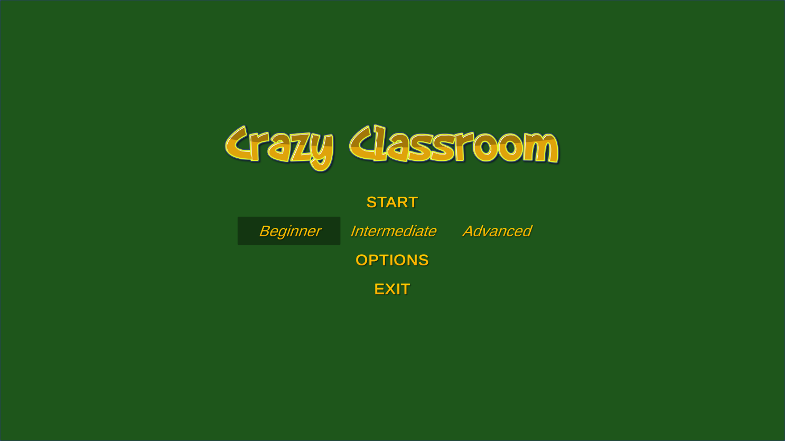While the modes are designed around grade levels, not every student is the same. Teachers are encouraged to start their students at a level that best matches their proficiencies. It may even be beneficial to work up from beginner regardless of how old the student is.

1. **Beginner**

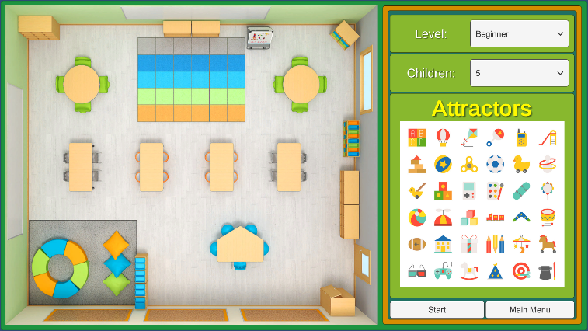Students will be presented with a ***Classroom Window*** and an ***Attractor Menu***. They can select an attractor from the ***Attractor Menu*** and it will appear in the ***Classroom Window*** and then press the ***Start Button*** to begin the simulation.

After running a simulation, the game will add the time it took the class to assemble to the ***Time List***. Once all simulations have been run, students will be asked basic questions about the results.

1. **Intermediate**

Students will be presented with a ***Classroom Window*** and an ***Attractor Menu***. They can select an attractor from the ***Attractor Menu*** and it will appear in the ***Classroom Window*** and then press the ***Start Button*** to begin the simulation.

Students will also be able to view how much interest the class has for each attractor. This will be displayed when hovering over an attractor in the ***Attractor Menu*** as a five-star rating.

After running a simulation, the game will add the time it took the class to assemble to the ***Time List***. Once all simulations have been run, students will be asked basic questions about the results.

At any point, students can press the ***Graph Button*** to access the ***Graph Window***. This window displays a graph of the tested attractors’ interest levels and the time they took to attract all the children. The **Classroom Button** can then be pressed to return to the **Classroom Window**.

1. **Advanced**

Students will be presented with a ***Classroom Window*** and an ***Attractor Menu***. They can select an attractor from the ***Attractor Menu*** and it will appear in the ***Classroom Window*** and then press the ***Start Button*** to begin the simulation.

Students will also be able to view how much interest each student has for different types of attractors. This will be displayed when hovering over a student in the ***Classroom Window*** as a five-star rating.

After running a simulation, the game will add the time it took the class to assemble to the ***Time List***. Once all simulations have been run, students will be asked basic questions about the results.

At any point, students can press the ***Graph Button*** to access the ***Graph Window***. This window displays a graph of the tested attractors’ interest levels and the time they took to attract all the children. The ***Classroom Button*** can then be pressed to return to the ***Classroom Window***.

**Options**

Sound is a major aspect of Crazy Classroom. An ***Options Menu*** can be accessed by pressing the ***Options Button*** where volume and ***Voice-Over*** settings can be adjusted.

**Features**

**Voice-Over**

Voice-overs are used to provide quick exposition, tell stories, narrate, and provide an intimate look into the mind of a character. For this game, a voice-over will be used to help those who are still learning to read. All prompts will be read out loud. This setting is automatically ON, but an option will be provided to turn it OFF for those who are not in need of assistance.

**Classroom Window**

The Classroom Window displays a top-down view of the classroom. This is where the children will be wandering around looking for something interesting. Based on complexity level, some additional information about the children may be visible here.

**Level Selector**

The Level Selector allows the teacher to select the complexity level. Higher complexity will increase the options and interaction for the users, introducing more factors for how the students roam.

**Attractors**

Attractors are the various toys and games that entice children to spots in the room. Higher complexity levels will add more factors to how attraction is calculates. Attractors can be found in the Attractor Menu.

**Start Button**

Once all the attractors are selected, hitting the Start Button will begin the simulation. The simulation will end once all kids have gathered in the designated areas.

**Menu Button**

The Menu Button returns the player to the main menu.

**Time List**

The times for completed simulation runs are kept in the Time List. Students will be able to compare results for different iterations of the simulation here.

**Graph Window**

Higher complexity levels will allow for the Time List to be visually represented by a graph. This will pop up over the Classroom Window.